

**SMARTe Goal**

By the end of the School Year, 100% of all students will show growth in their ability to comprehend developmentally appropriate texts as measured by our internal assessments. (STEM scopes, Nearpod, Edmentum, Lexia Learning, IXL, and district assessments)

100% of all students will show a minimum SGP between 35-60 points for students in grades 2-8 for math and reading. (STAR Reading and STAR Math Assessments)

100% of all students in grades K-1 will progress as evidenced by the daily learning experiences for reading, math, and science with Apple products as a resource.

By the end of the school year, 100% of the teaching staff will implement monthly student-oriented lessons in reading, math, science, and or history, as Apple Certified Teachers to support the use of APPLE products for technology as a resource and S.T.E.M. for student engagement monthly in all content areas.

**Southside STEM Academy at Campostella**

**School-wide Instructional Strategies**

|  |  |
| --- | --- |
| **Justification**   * Use the word interchangeably with “prove, show, tell”, but always say JUSTIFY! * Could it be a drawing, a sentence, a paragraph #, or a graphic organizer * Justify why the wrong answers are wrong and the right answers are right |  |

**Higher Level Questioning**

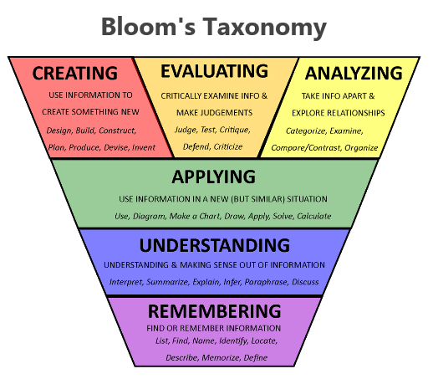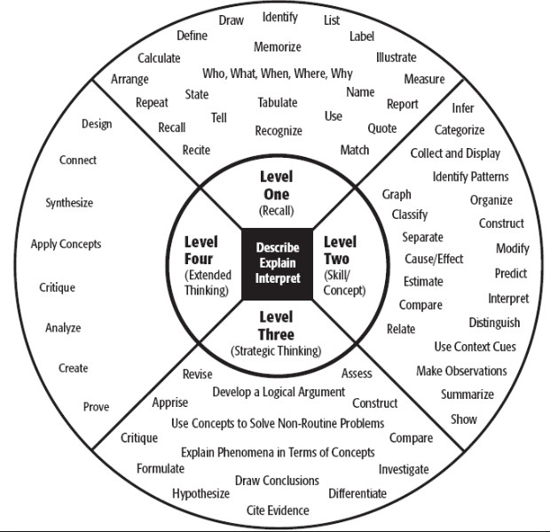

**Vocabulary Development**

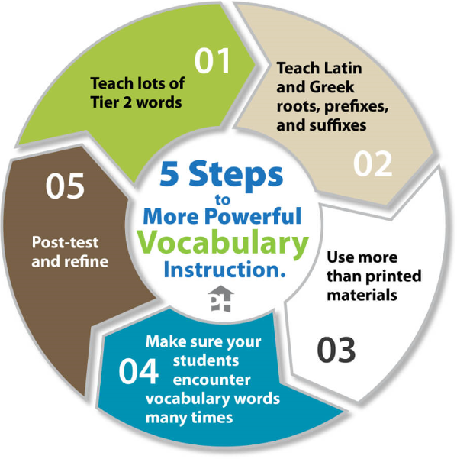



**Mission Statement**

Southside S.T.E.M. Academy at Campostella program incorporates Problem and Project-Based learning with a special emphasis on the area of Engineering. The purpose is to increase early student value and awareness in S.T.E.M. areas (Science, Technology, Pre-Engineering, and Mathematics) while preparing them with 21st Century skills necessary to meet the future demands of a globally competitive workforce.



**Vision**

The vision for Southside STEM Academy at Campostella is to provide an academically challenging learning environment for K-8 students with S.T.E.M. as a focus through reading comprehension embedded in all content areas of reading, math, science, history, and writing. Students will experience a rigorous curriculum, augmented with science, technology, engineering, and mathematics concepts. Through the integration of problem and project-based inquiry activities, critical thinking skills will be fostered and authentic learning experiences will be provided.

**Instructional Focus**

The instructional focus for Southside STEM Academy at Campostella is S.T.E.M. (Science, Technology, Pre-Engineering, and Mathematics) with a direct focus on engineering and reading comprehension in all content areas with Apple as a resource to foster the strategic move from low student achievement to high student achievement.

**Student Friendly Statement**

**SSAC can’t be stopped**

**With active reading**

**We’ll score to the top!**

**Daily Affirmation**

**I am somebody**

**And I will achieve great things!**

Welcome Back Southside STEM Academy at Campostella School Family,

The new school year is finally here! Welcome Back Everyone. A special warm welcome is extended to all of our new families. We will have an awesome school year on purpose with purpose. Here at Southside STEM Academy at Campostella, we are committed to equity and excellence for all of our students. We strongly believe in the motto that **“Teamwork Makes the Dream Work!”**

Teaching and learning are extremely important and will include a variety of STEM experiences throughout all content areas. We will achieve academic success at Southside STEM Academy at Campstella. We will serve with a sense of urgency by aiming to bring STEM (Science, Technology, Engineering, and Mathematics) to life for every child who enters our school by providing rigorous and engaging lessons.  We will focus on developing our school-wide instructional strategies of justification, higher-level questioning, and vocabulary development with an emphasis on STEM in all we do daily.

Our staff is committed to communicating with you to support your child’s educational journey at Southside STEM Academy at Campostella. Communication from Southside STEM Academy will come through the monthly newsletter entitled the “Cardinal Tweet” which will be posted on our school website along with other important information. We will communicate with our families through Blackboard Connect Robo-call System which we highly encourage you to listen to for important information from our school. Our teachers will communicate with you via email as needed. Our middle school teachers will communicate via Google Classroom and all teachers will communicate via Class Dojo to communicate with you. Please download this app to your device as soon as possible.

Our goal is to make every child’s learning experience positive. Should you have questions or concerns during the school year, please contact me via email at llwillie@nps.k12.va.us. I look forward to an awesome school year with rigorous instruction for all students at Southside STEM Academy at Campostella. Again, welcome!

Sincerely,

Lenthia Willie-Clark